|  |
| --- |
| Table of Contents  Q1. Build a big data processing pipeline 2  1 Data Pipeline Setup in Azure Data Factory 2  2 Processing IoT Sensor Data Using Azure Databricks 5  3 Storing Structured Data in Cosmos DB 8  Q2. Restore and query an SQL database on the cloud 10  1 Restore the database from the given backup 10  i. What is the catalogue of all products along with their categories and unit price? 11  ii. What were the top performing product categories by the total revenue generated? 11  iii. Who were the top performing employees by the number of orders handled? 12  2 How would you automate the restoration process to ensure business continuity in future incidents 14  Q3. Conduct an exploratory analysis of the NYC Taxi Limousine Commission dataset using Databricks 14  i. Estimate the carbon emissions for each taxi ride. using the following emission factor: 8.89 kg of CO2 per gallon of gasoline burned 15  ii. Plot the total emissions per day over the year, comparing rides with 1-2 passengers versus rides with larger groups (3 or more passengers) 15  iii. Based on your analysis, suggest ways to reduce carbon emissions from taxi rides. Provide practical recommendations based on your findings 16  Q4. Setup a showcase using GitHub 17 |

# Q1. Build a big data processing pipeline

## 1 Data Pipeline Setup in Azure Data Factory

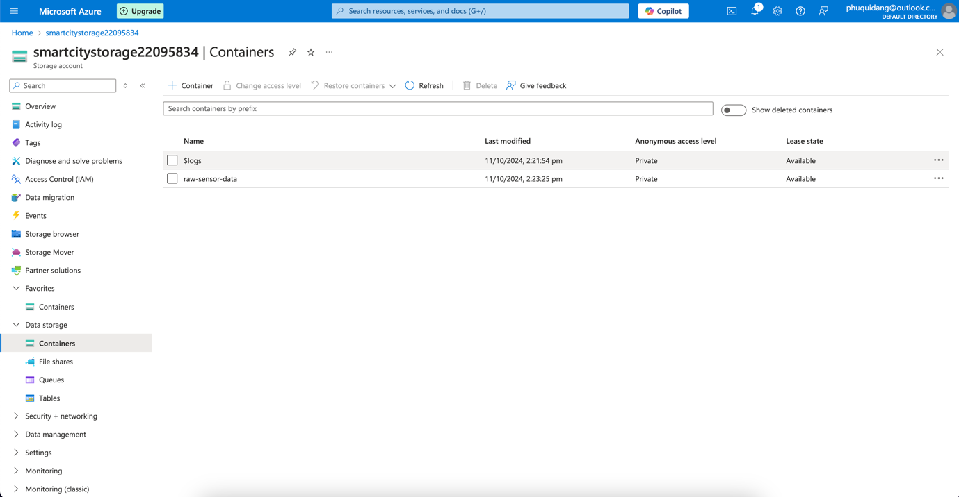

For Task 1 of Question 1, I created the computing environment for the data source required for IoT sensors. I named it 'raw-sensor-data' within Azure Blob Storage and created it under a storage account named smartcitystorage22095834. This includes data from the IoT sensors in the urban fabric, such as air quality, traffic, energy, or any other sensor data. Also, the stored data will be appropriately processed using the Health Azure Data Factory and Databricks later. This well-organized framework helps ensure that the data is stored safely and efficiently processed for the next steps.

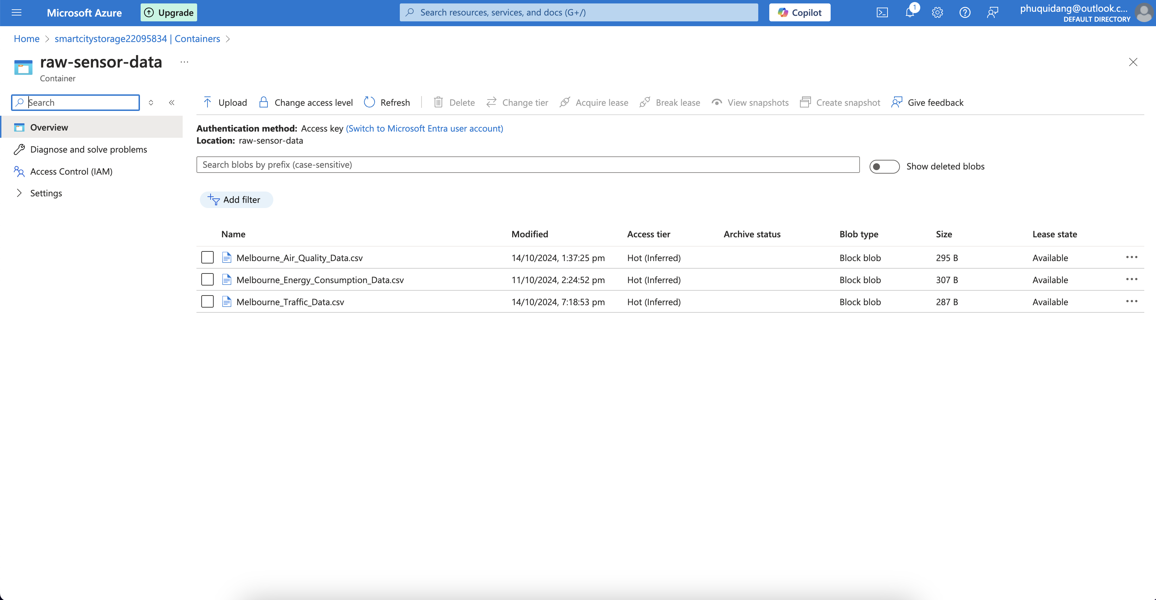

The next step was to add three datasets to the "raw-sensor-data" container in Azure Blob Storage. These datasets are as follows,

Melbourne_Air_Quality_Data.csv features air quality sensor data.

Melbourne_Energy_Consumption_Data.csv illustrates the data on energy consumption behaviours.

Melbourne_Traffic_Data.csv – traffic sensor data included in this one.

These datasets were uploaded as Block Blob data and will be used as the primary information in the pipeline. I kept everything in the "raw-sensor-data" container, though, to contain everything while it is straightforward to retrieve the data for further stages of the extraction and processing.

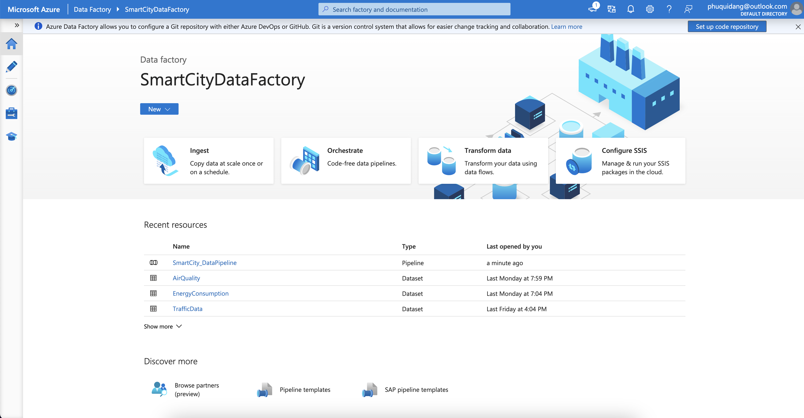

In this step, I set up an Azure Data Factory environment called SmartCityDataFactory. This data factory orchestrates the movement of data from Azure Blob Storage to further stages of processing. Within this Data Factory, I created the following resources such as SmartCity_DataPipeline: The primary pipeline that manages the flow of data from the storage into processing tasks. AirQuality, EnergyConsumption, and TrafficData: Datasets representing the corresponding CSV files previously uploaded to the Blob storage. These datasets are mapped to their respective blob containers for further ingestion and processing in Databricks. This step lays the foundation for building the data processing pipeline by defining the source datasets and initiating the pipeline.

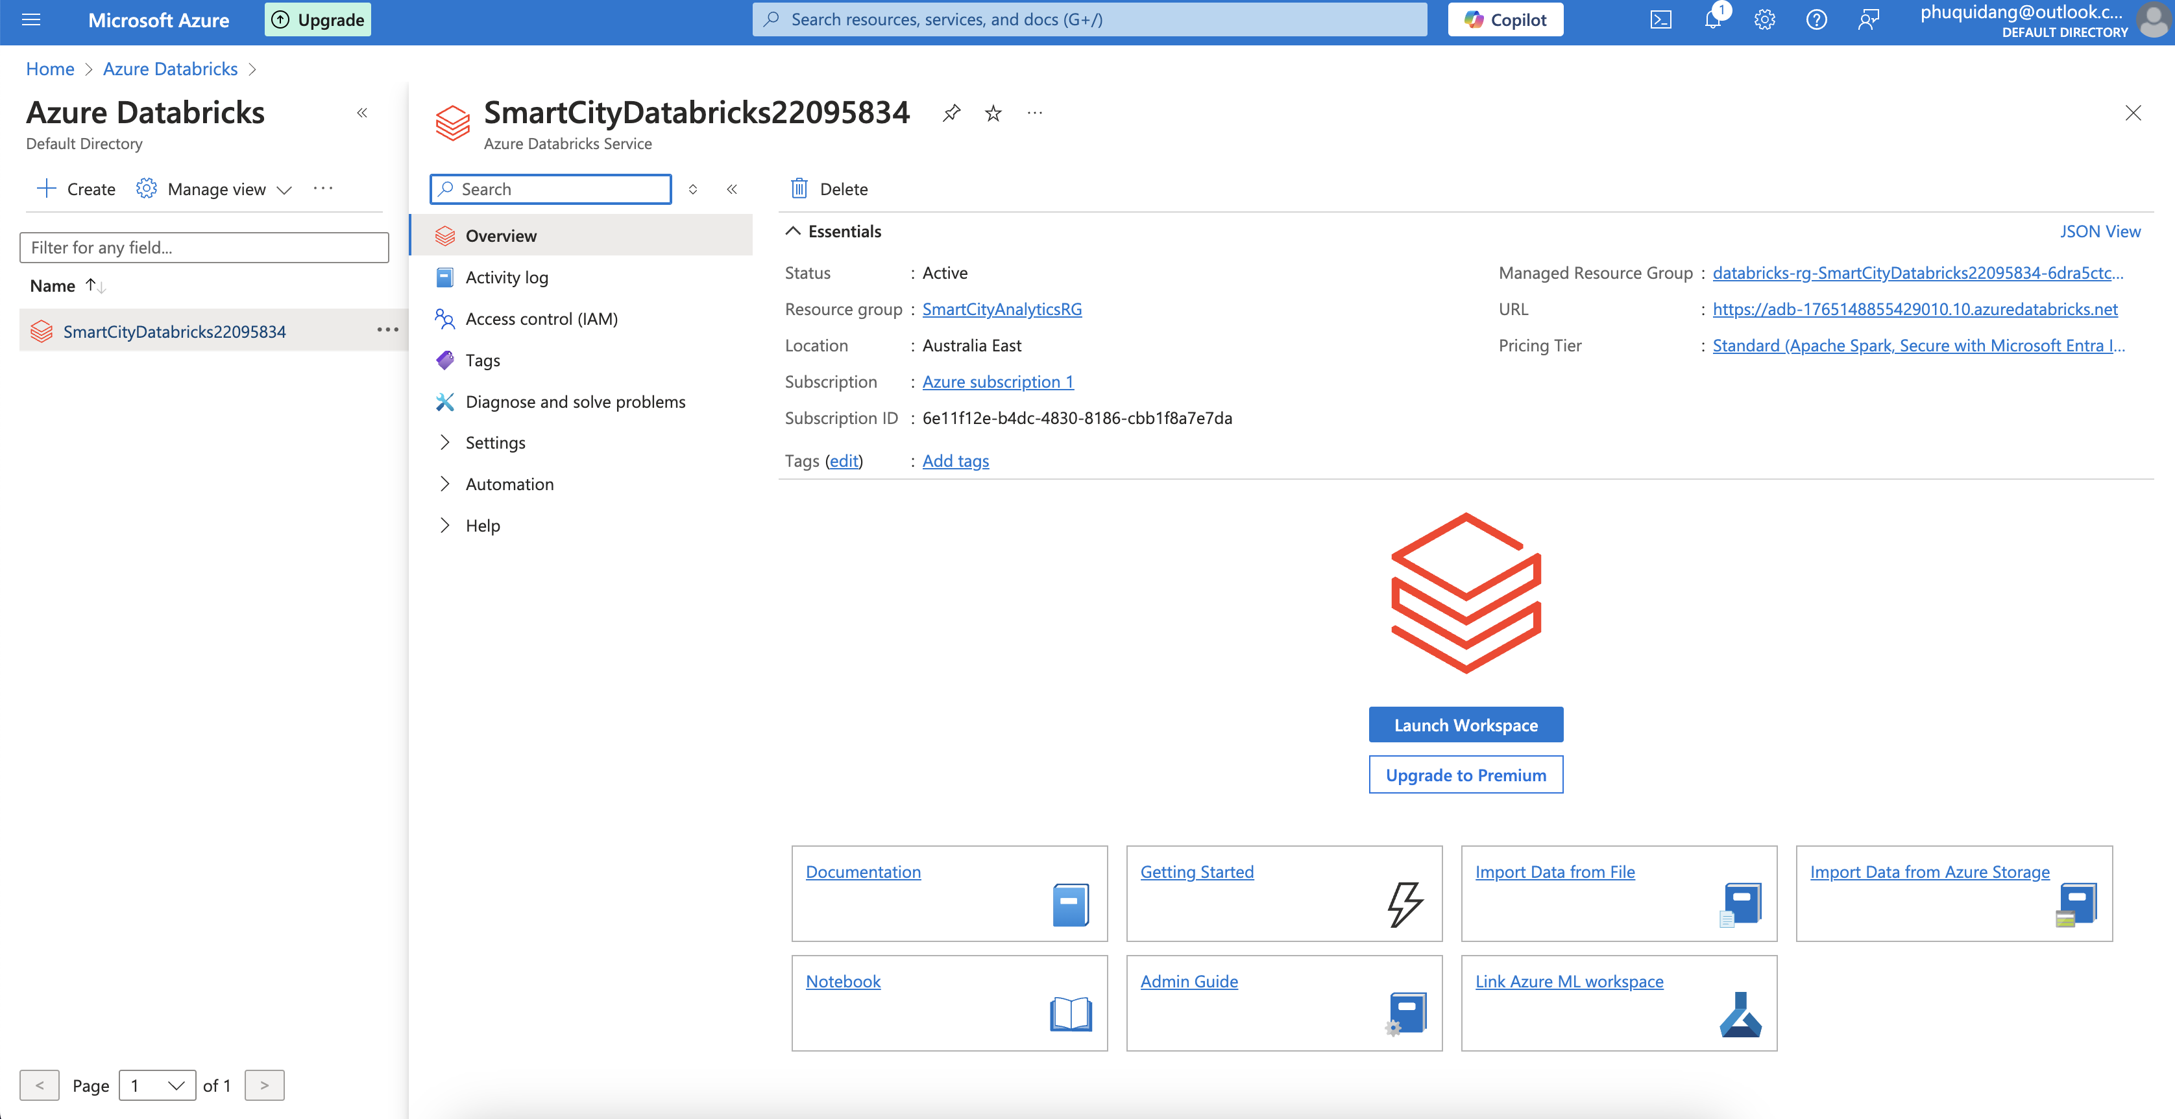

SmartCityDatabricks22095834 Azure Databricks environment is created. Based on the basic features of the Azure Databricks data processing platform, one can use it to consume and analyse any form of data generated by the factory pipeline. I have initialized the workspace of Databricks, where I will write code in notebooks that extract the sensor data. For sure, Databricks environment has been set towards the same SmartCityDataPipeline as the rest of the pieces of architecture; that is, there is a way for the data to be located on Databricks side, provided there are no technical issues. This step also ensures that every part of the Data pipeline structure is connected, including the Databricks workspace acquisition by the ingestion corresponding to the analysis.

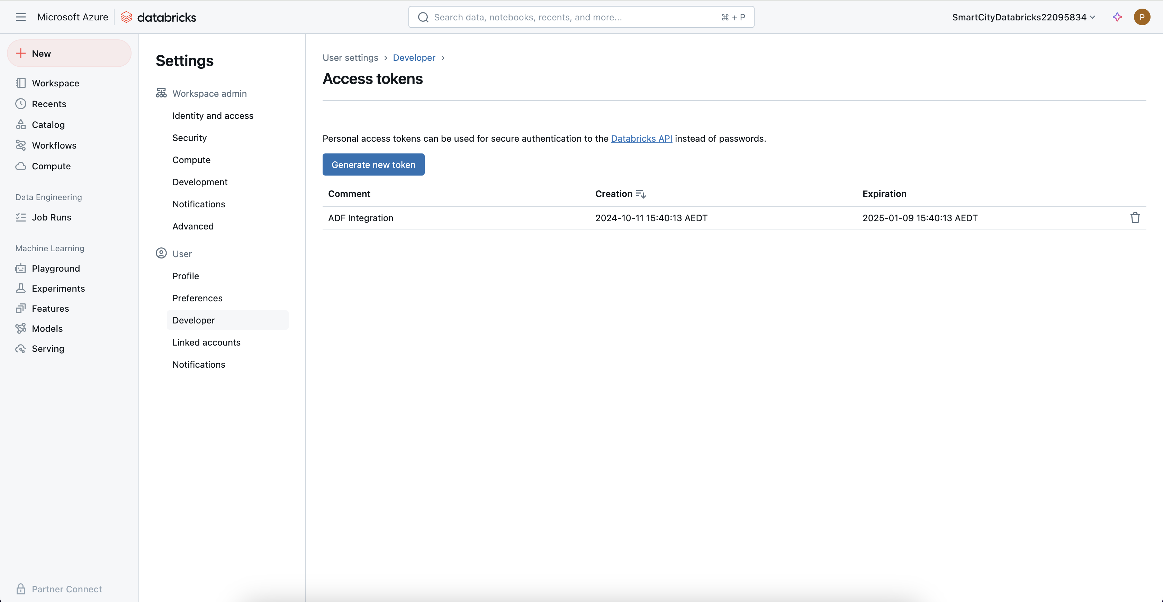

A user access key was created at the Databricks to allow easy access to the Databricks API while preventing unauthorized access. However, this was labelled an ADF Integration token, allowing Azure Databricks to interact with other Azure services such as Azure Data Factory (ADF). Such interaction automatizes the running and processing of data several times. The token also aids verification without depending on passwords and pushing data using ADF into the Databricks, enhancing security control and ease of data processing. The token’s lifespan is constrained because it can be deactivated or deleted for security purposes.

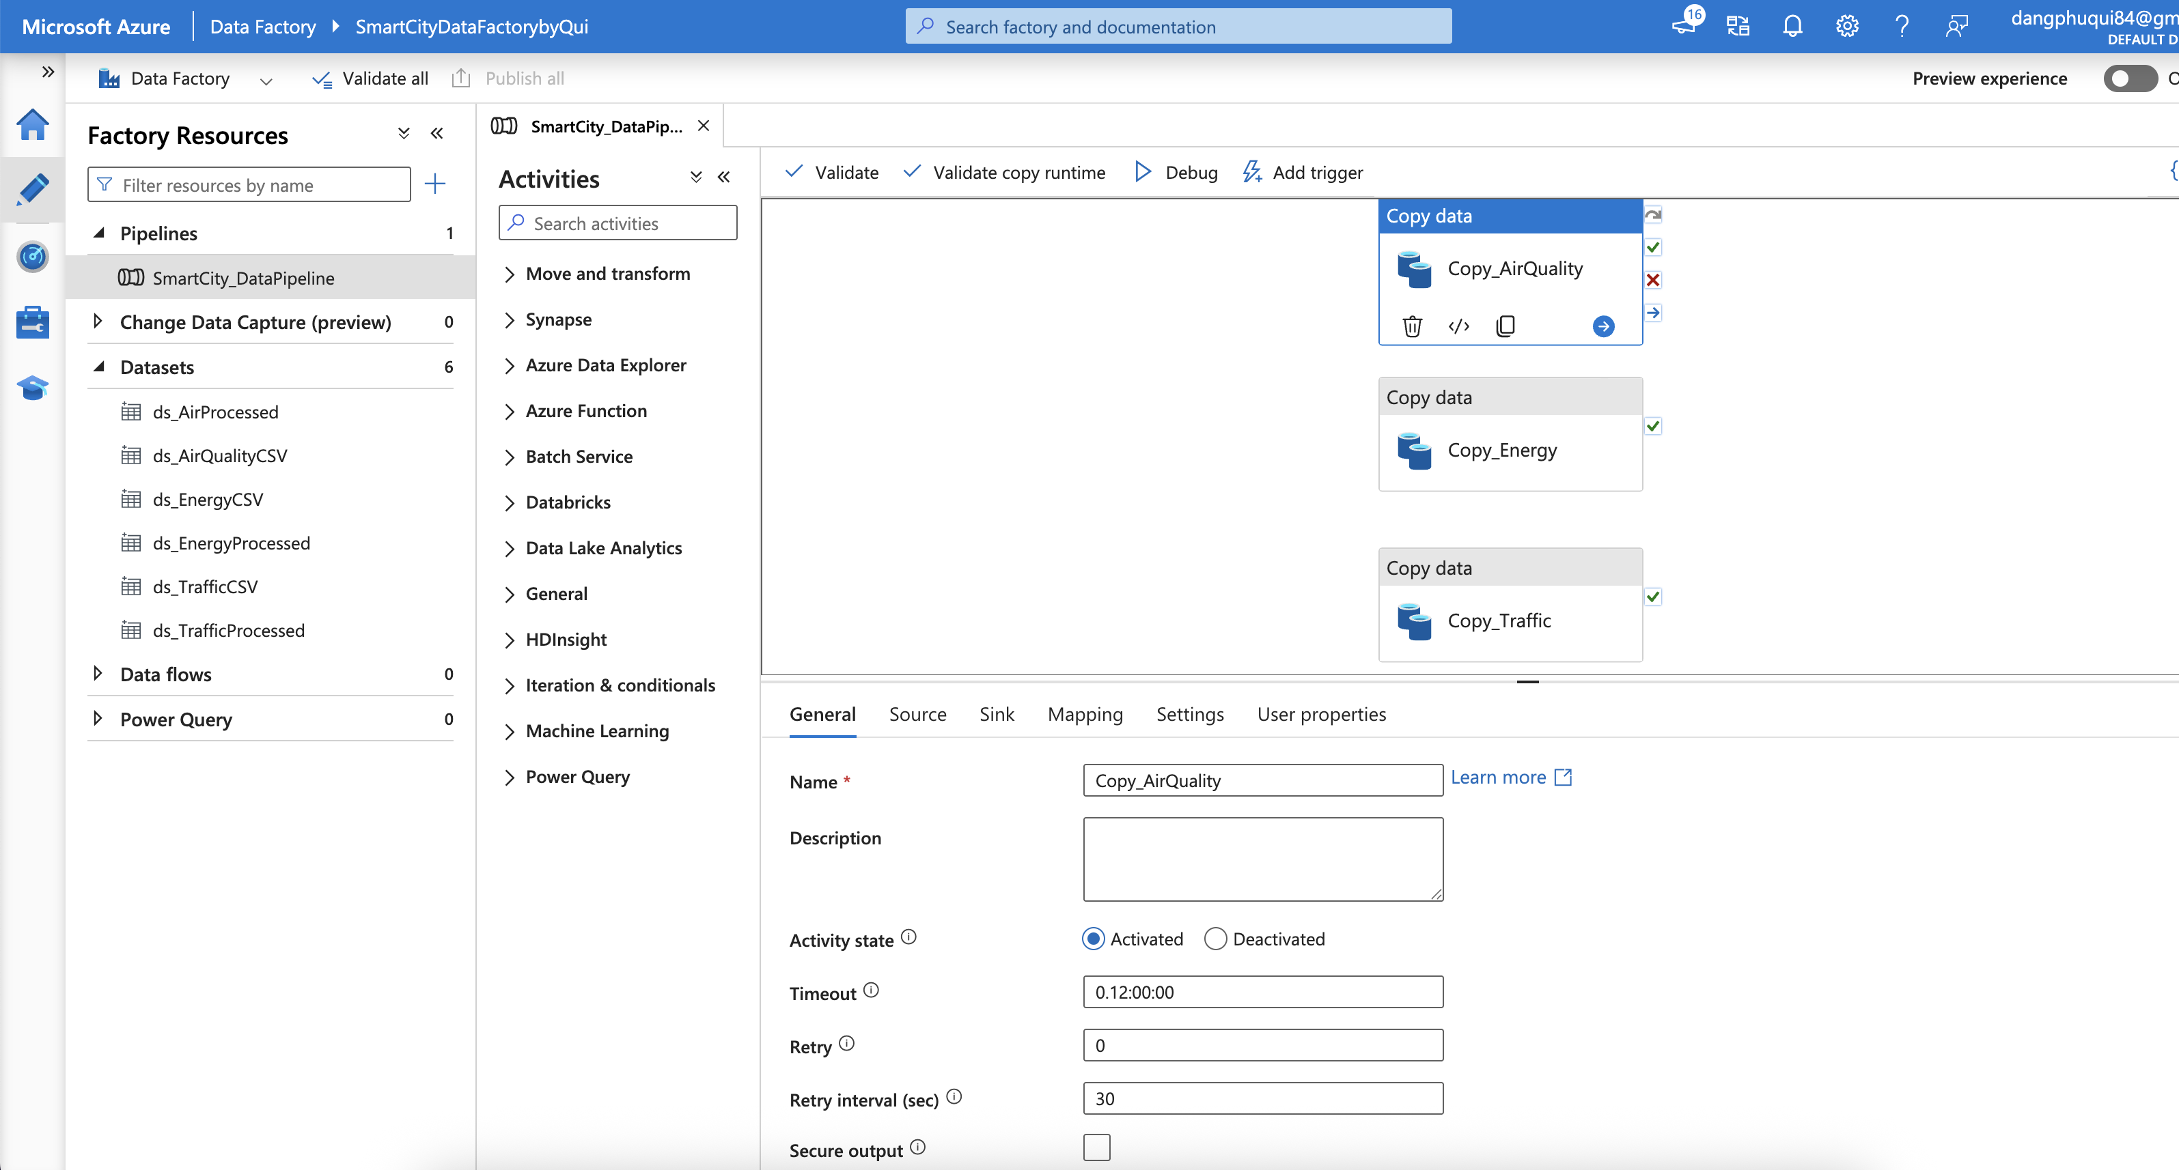

A Copy Data activity was created within Azure Data Factory to transfer data from various IoT sensor datasets such as AirQuality, EnergyConsumption or TrafficData activity as Copy Data activity was created. Source datasets are extracted from the Azure Blob Storage container and associated with energy consumption data. This action is mainly used to help move the data and ensure that whenever a file containing the said data is created, the data will be copied, along with arrangements made to enhance the data to be used in analytic services through Azure Databricks. The settings used transfer recursive folders and partition information to ensure that all the relevant files are found and processed quickly even if they are not all in the same place.

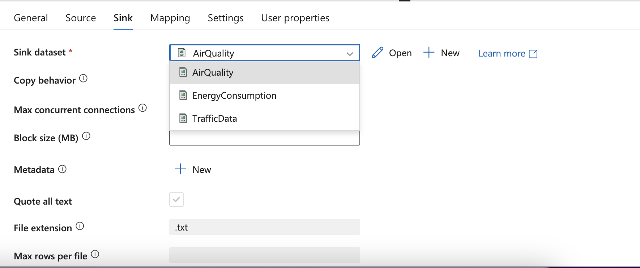

The Sink dataset is set up so the Copy Data activity can be used in the Azure Data Factory. In this context, the Sink is where the relevant output of all that extractive work is placed after retrieval. Since the exercise calls for a copy action on sensor files as specified earlier, the Sink comprises sink datasets such as AirQuality, EnergyConsumption, and TrafficData to enable placement of the collected sensor data in the suitable storage location for further action. The operation also tweaks file corruptions, data compression, and the violation of bugs, even when triggers use threads with transfers, which speed up the copying rate.



The SmartCity_DataPipeline in Azure Data Factory was successfully initiated and narrowly executed. The pipeline fragment in the display is Copy_IoT_Sensor_Data, completed without errors, as the green checkmark indicates. This, in simpler terms, means that the pipeline was able to move the data of the sensors of the various IoT devices in the source system (Blob Storage) to the target location, and the data was preserved in the respective datasets for further processing and study. The run status of the pipeline gives detailed information such as the start time, the duration of the run, and the respective activity ID for monitoring and troubleshooting purposes.

## 2 Processing IoT Sensor Data Using Azure Databricks

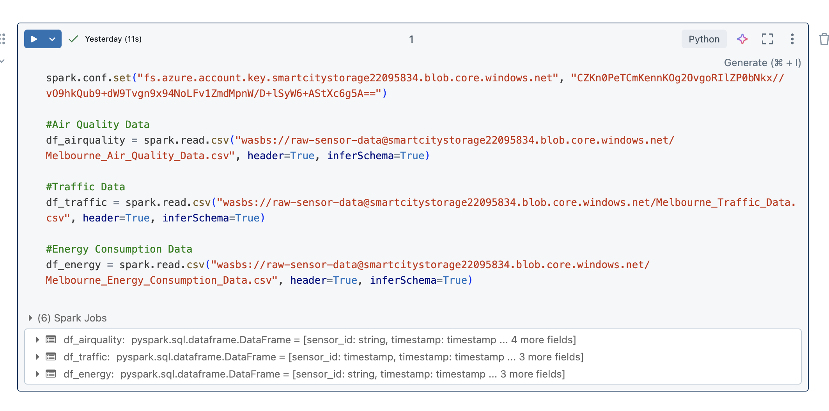

The raw information gathered from sensors or other units that measure air quality, traffic levels or energy use is being analyzed using the spark.read.csv() functionality from Databricks. This method retrieves the information previously stored in CSV files about the sensor data as uploaded to the Azure Blob Storage. The data is inputted with headers, and schema inference is enabled, which allows the system to automatically comprehend the structure of every column and the data type involved. In this case, data is input from three different sources: Air Quality Data: This data contains objects of an Air Quality Index, PM, PM2.5, PM10 and their associated timestamps. Traffic Data: This includes traffic sensor data and traffic count, speed, and stock location data. Energy Consumption Data: This section concentrates on the consumption of energy in different regions of the city, peak demand and their respective timestamps. The results obtained from this information processing, namely the processed data, are presented into DataFrames (df_airquality, df_traffic, df_energy) and can be used for scrutinizing further to come up with key metrics, for example, average air quality scores, traffic indexes and power consumption by regions. Such reports are essential when dealing with sensor data from particular places within the city, as they allow comparisons.

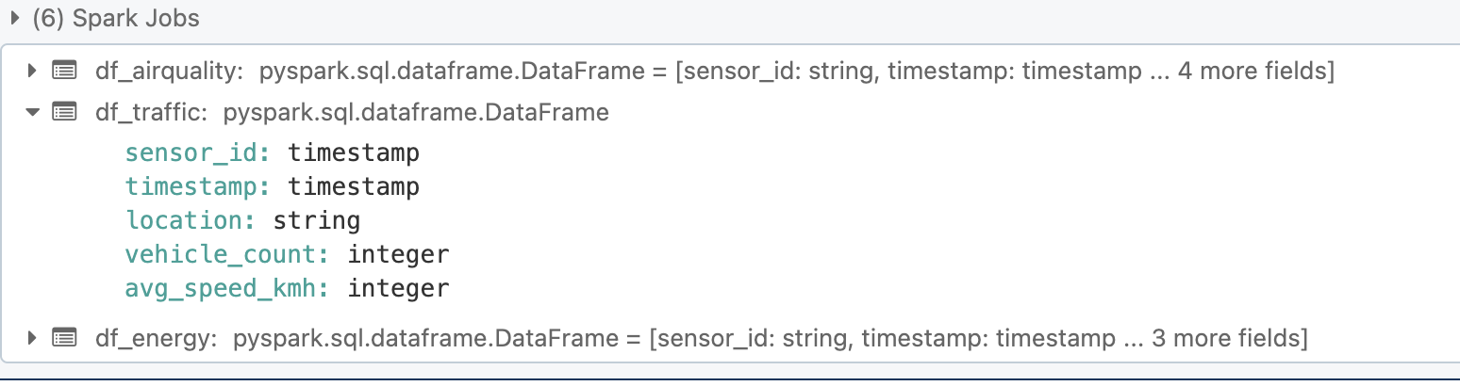

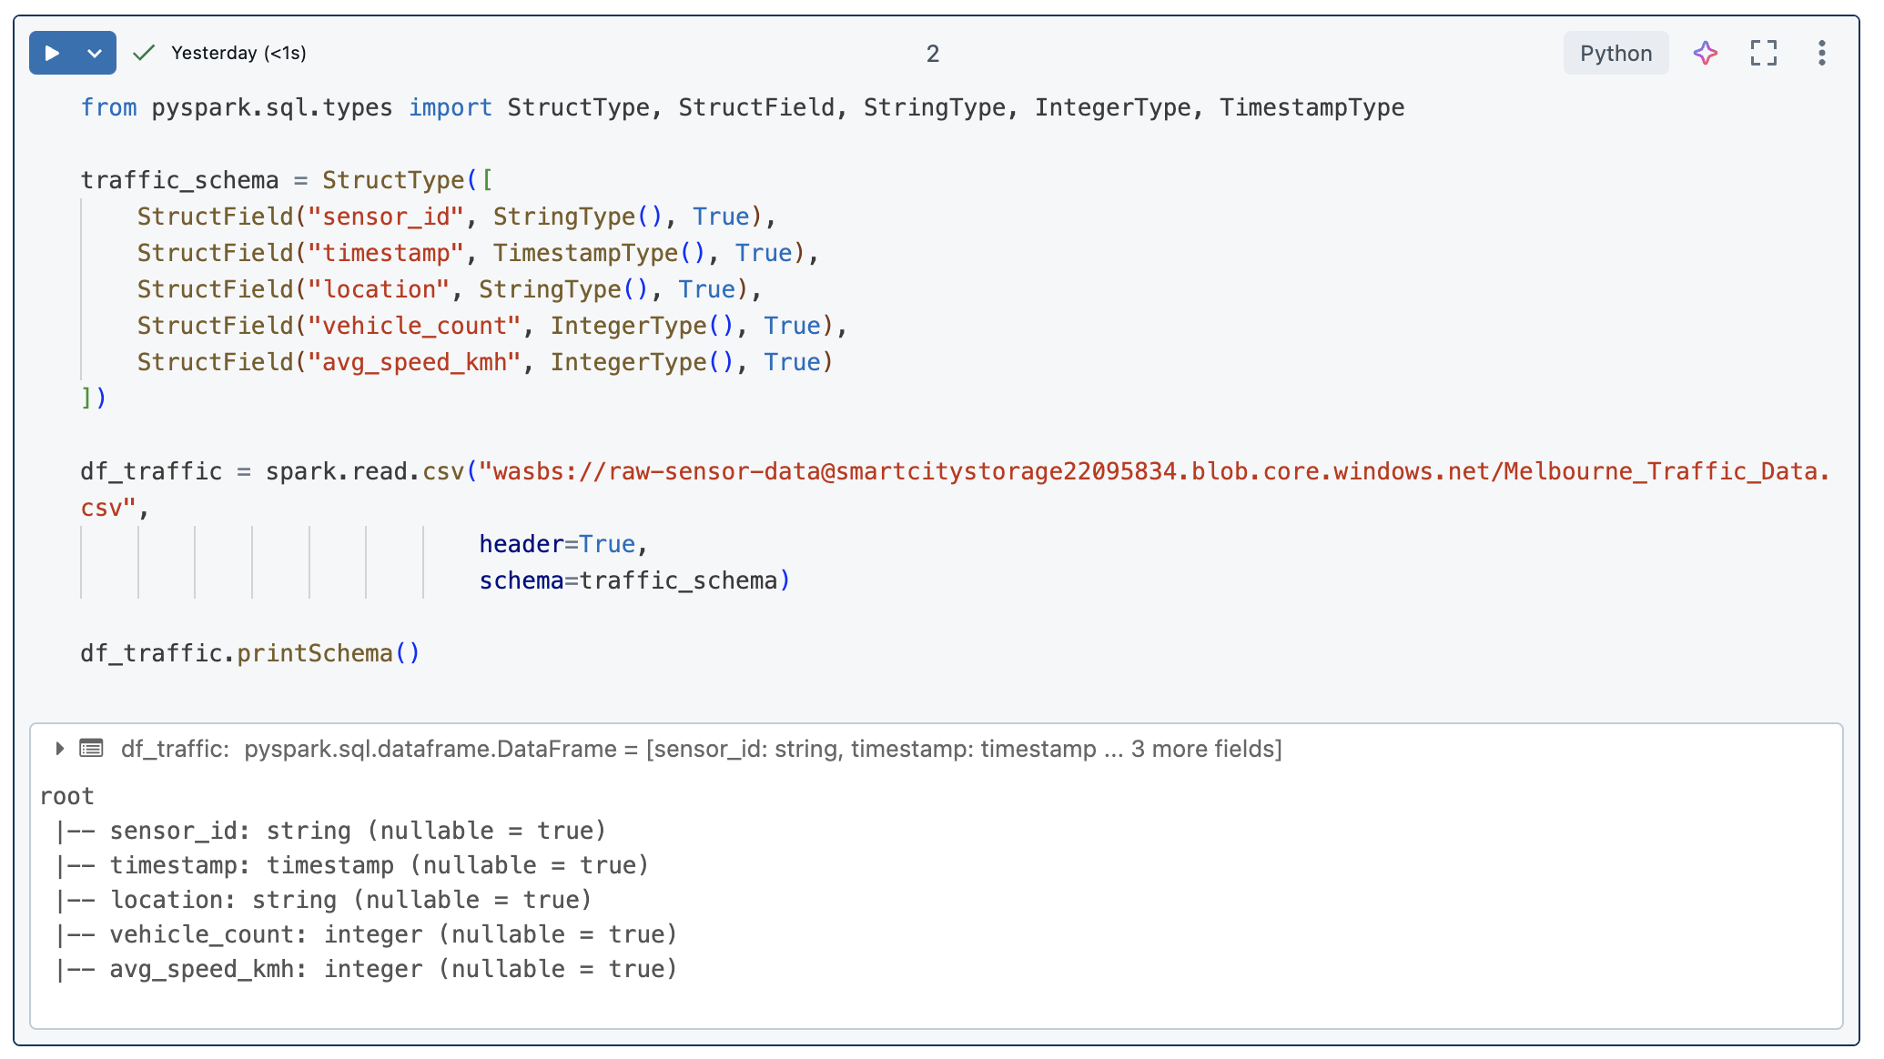

While examining the traffic statistics, we detected that the sensor_id field had a data type problem. In particular, the data format analysis exposed that instead of sensor_id being a string, it was wrongly considered as a timestamp. In order to fix it, a format was constructed, and the sensor_id was demonstrated as a String using the StructType function. However, the other fields, such as timestamp, locality, number of vehicles, and speed, were left intact. The revised plan was further utilized to retrieve the data in CSV, and the revised structure was checked by outputting the available data frame into the console.

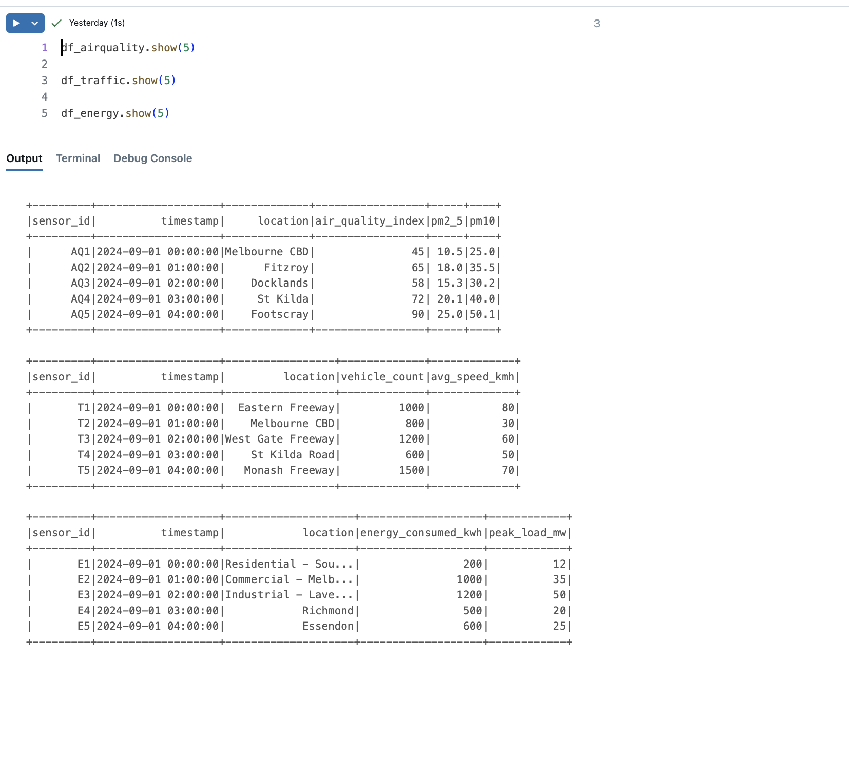

From the three data sets on processed data containing air quality, traffic and energy consumption, it is confirmed that straightforward data is interpreted and can be accepted. Using Databrick, the .show () function was employed to check the first five rows of each data set quickly. Description of Data: It depicts sensor readings in different locations, e.g. Melbourne CBD and Fitzroy, and has fields like air quality index, pm2 5, and pm10 that account for different levels of particulate matter. Traffic Data is for traffic indicators such as vehicle_count and avg_speed_kmh in locations like Eastern Freeway and Melbourne. EnergyComsumption Data is for overall energy usage - it also shows other indicators, such as energy_consumed_kwh and peak_load_mw, during different times of demand zones, such as the Residential Areas in South Melbourne and Richmond.

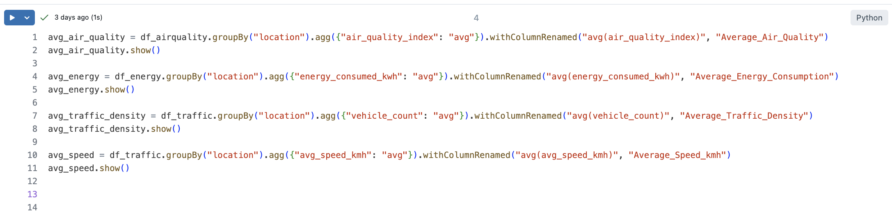

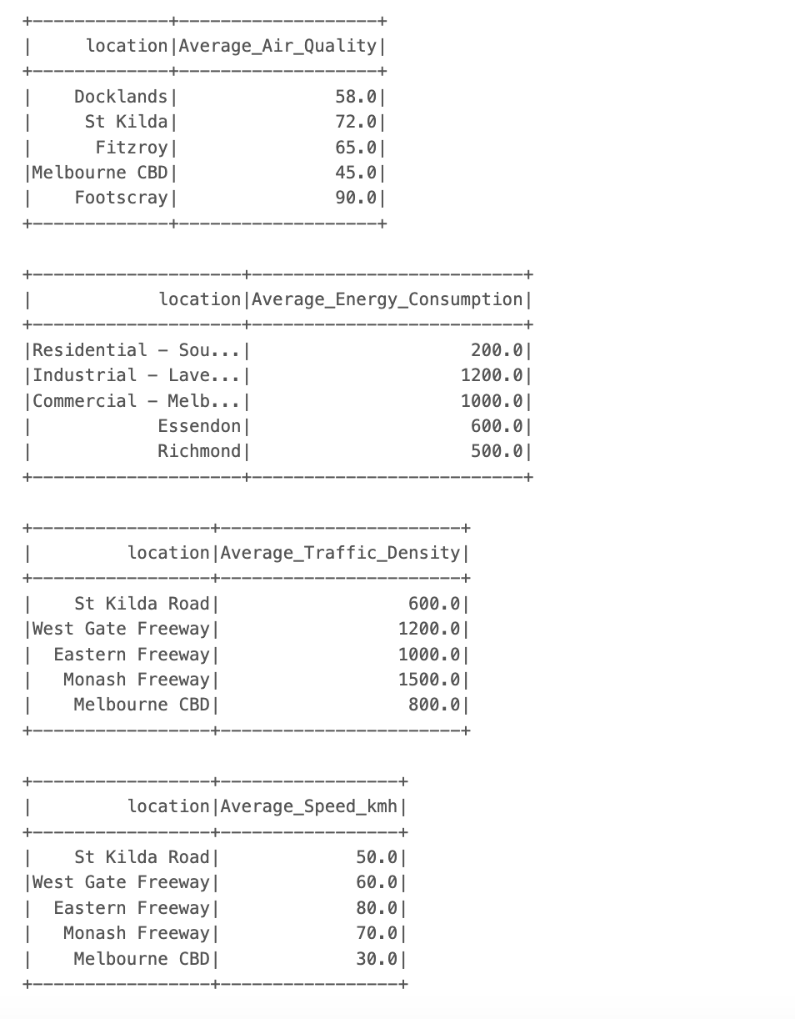

This part of the code computes the average air quality index, power consumption, traffic congestion, and vehicle speed per different localities in Melbourne. We list them and then use the aggregate function to give the average of each parameter. Air Quality: The location-specific air quality data is used first to determine the average air quality index. Energy Consumption: Similarly, energy consumed in kilowatt-hours (kWh) in each locality is averaged. Traffic Density: This time, traffic data is analysed, and the average traffic is generated for areas that consider the miscellaneous sections. Speed: Average vehicle movement speeds in each area are also established to present the movement of vehicles. The information contains several places within the city, such as St Kilda Road and Melbourne CBD, amongst other locations, where applicable, with metrics suitable for eco of municipal energy efficiencies. The evaluation has information from such sources that help determine which areas are most congested, have high energy demands, or have poor air quality, constituting a crucial part of urban development and organization study.

## 3 Storing Structured Data in Cosmos DB

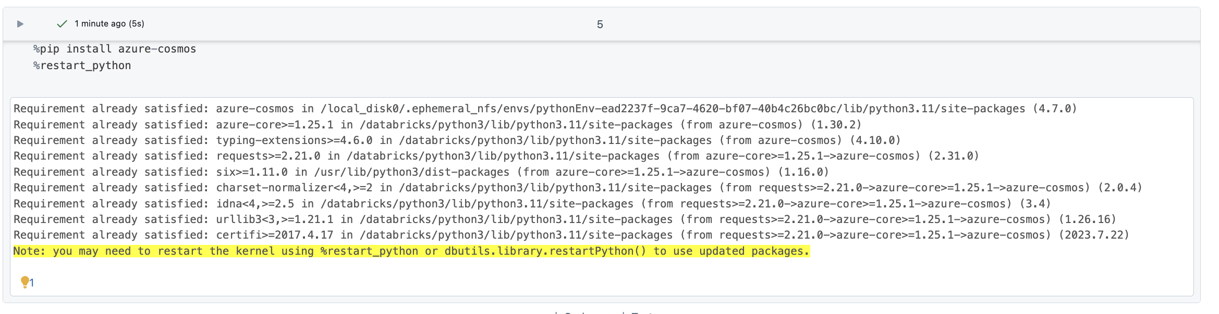

Install the necessary Azure Cosmos library on Databricks to enable seamless communication with the Cosmos DB environment.

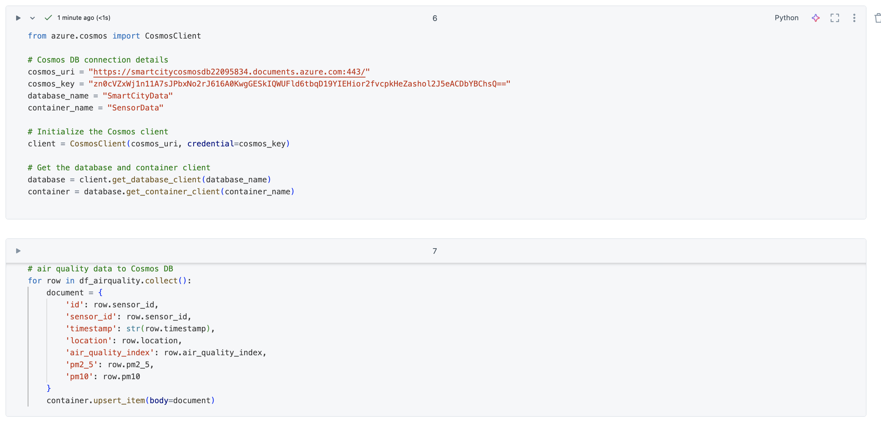

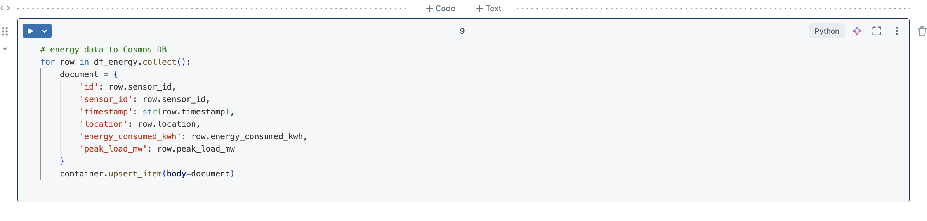

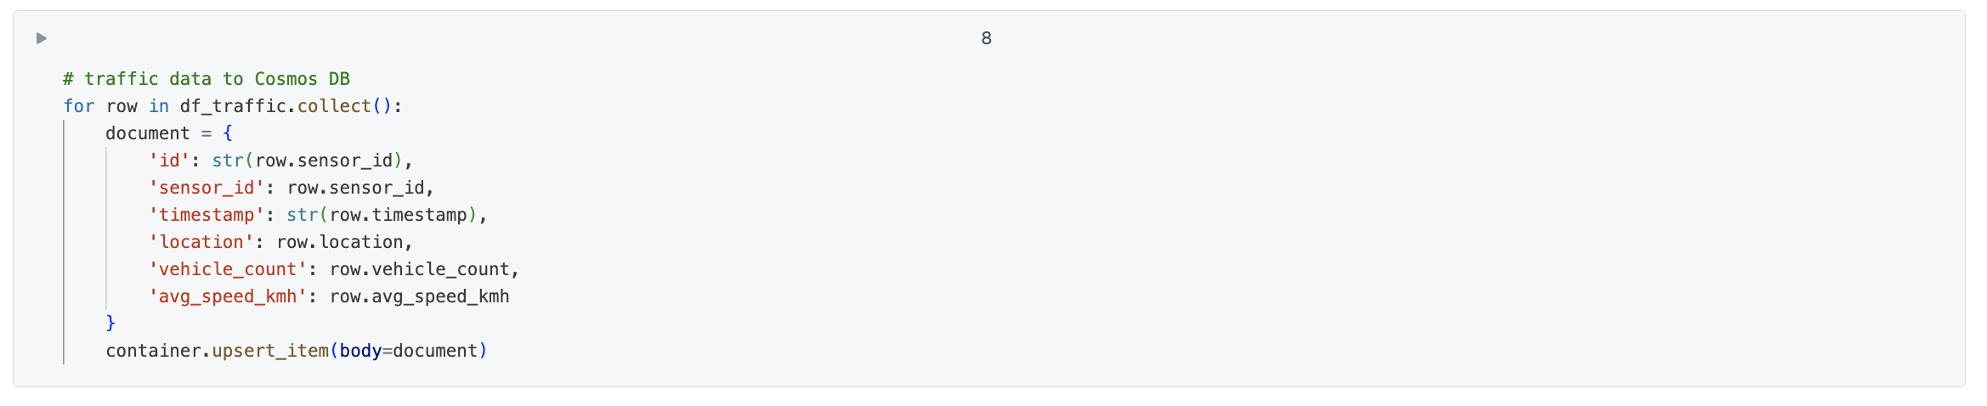

Azure Cosmos DB was connected to store air quality and energy consumption data. Using the Python SDK, the CosmosClient was initialized with the required URI, key, database, and container details.

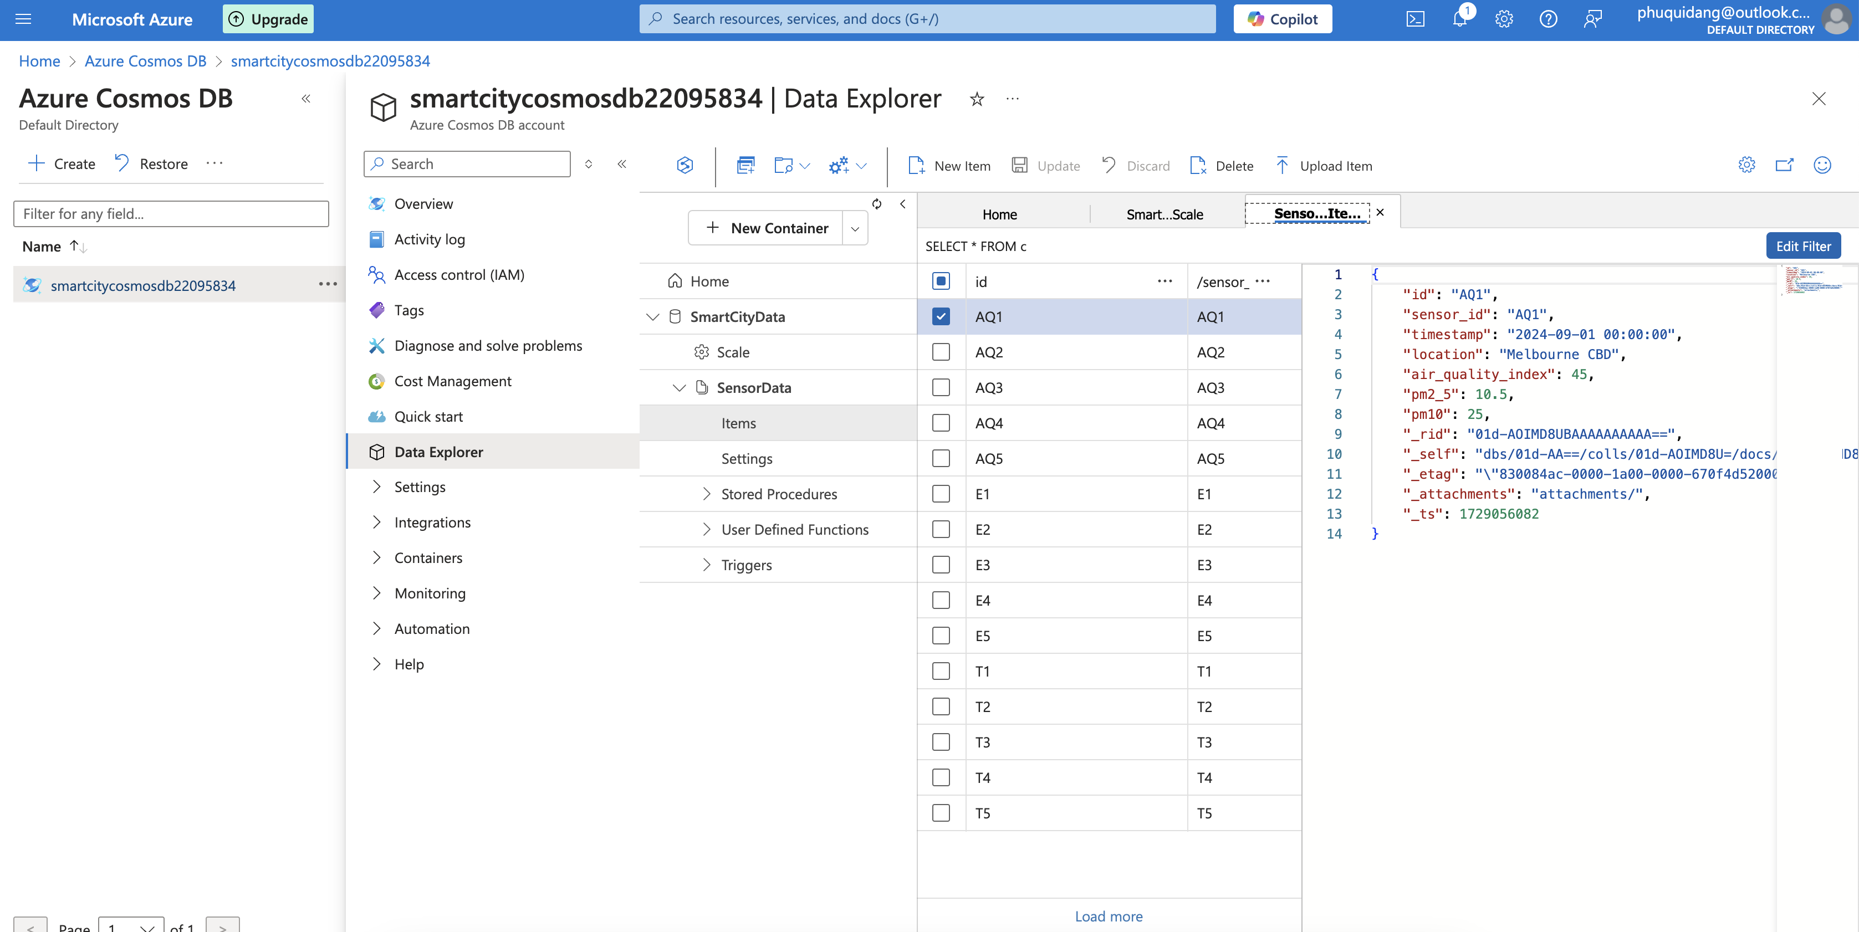

The data from Databricks have been instantly converted to JSON documents and are now in the Azure Cosmos DB. These documents are discretely held as a JSON string consisting of information fields: sensor ID, location, datetime, and critical variables like air quality index PM2.5 and PM10 particles. With this structure, the data can be easily stored and searched in the cosmos db, providing, in some cases, even comprehensive views based on the sensor data.

# Q2. Restore and query an SQL database on the cloud

## 1 Restore the database from the given backup

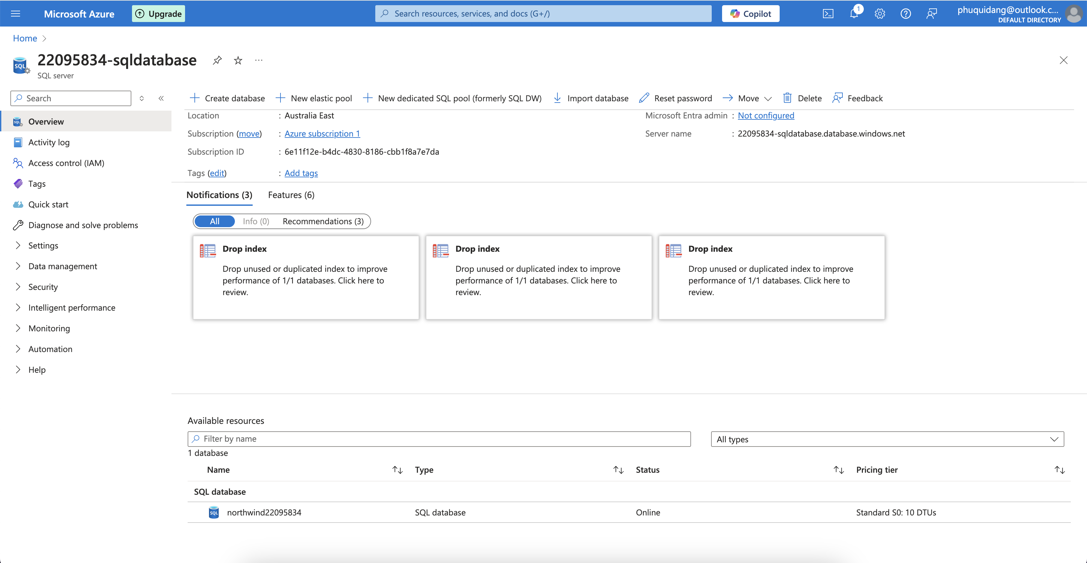

To assist in the restoration of the Northwind database, the first steps to creating a SQL Database in Azure were taken. This SQL Database will be committed as a target for the Northwind .bacpac file, which includes the entire schema plus data adoption. An Azure database named “northwind22095834” was developed in the context of the specific Azure SQL Server named 22095834-SQL database. The ideas about the need for what has been created also extend to understanding the restoration and retrieval of materials.

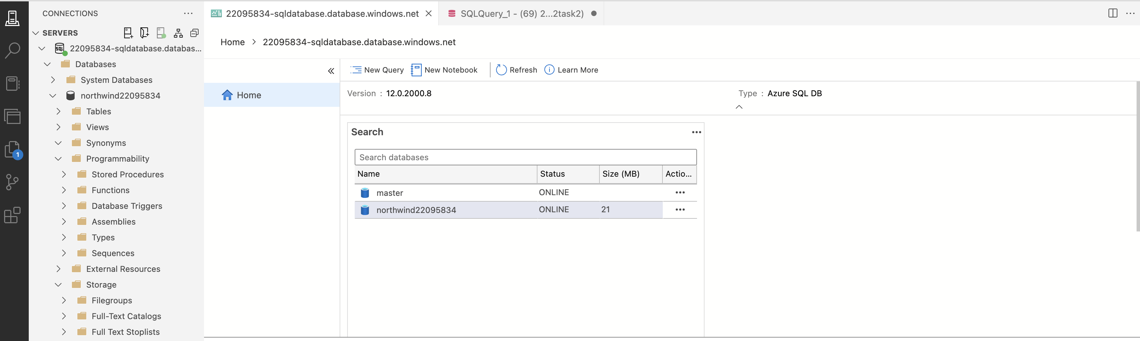

To work with the .bacpac file stores in the SQL database, a connection to the Azure Data Studio was needed. The Azure Data Studio is one of the most challenging and convenient environments in which to interact directly with the SQL database in the Azure cloud. A connection was successfully made to the SQL Server among the 22095834-sqldatabase.database.windows.net, which has the specified working space called nerthwind22095834 database. This installation provides the necessary environment for querying and managing the Northwind data. Moreover, the established connection showed that the database could be easily accessed.

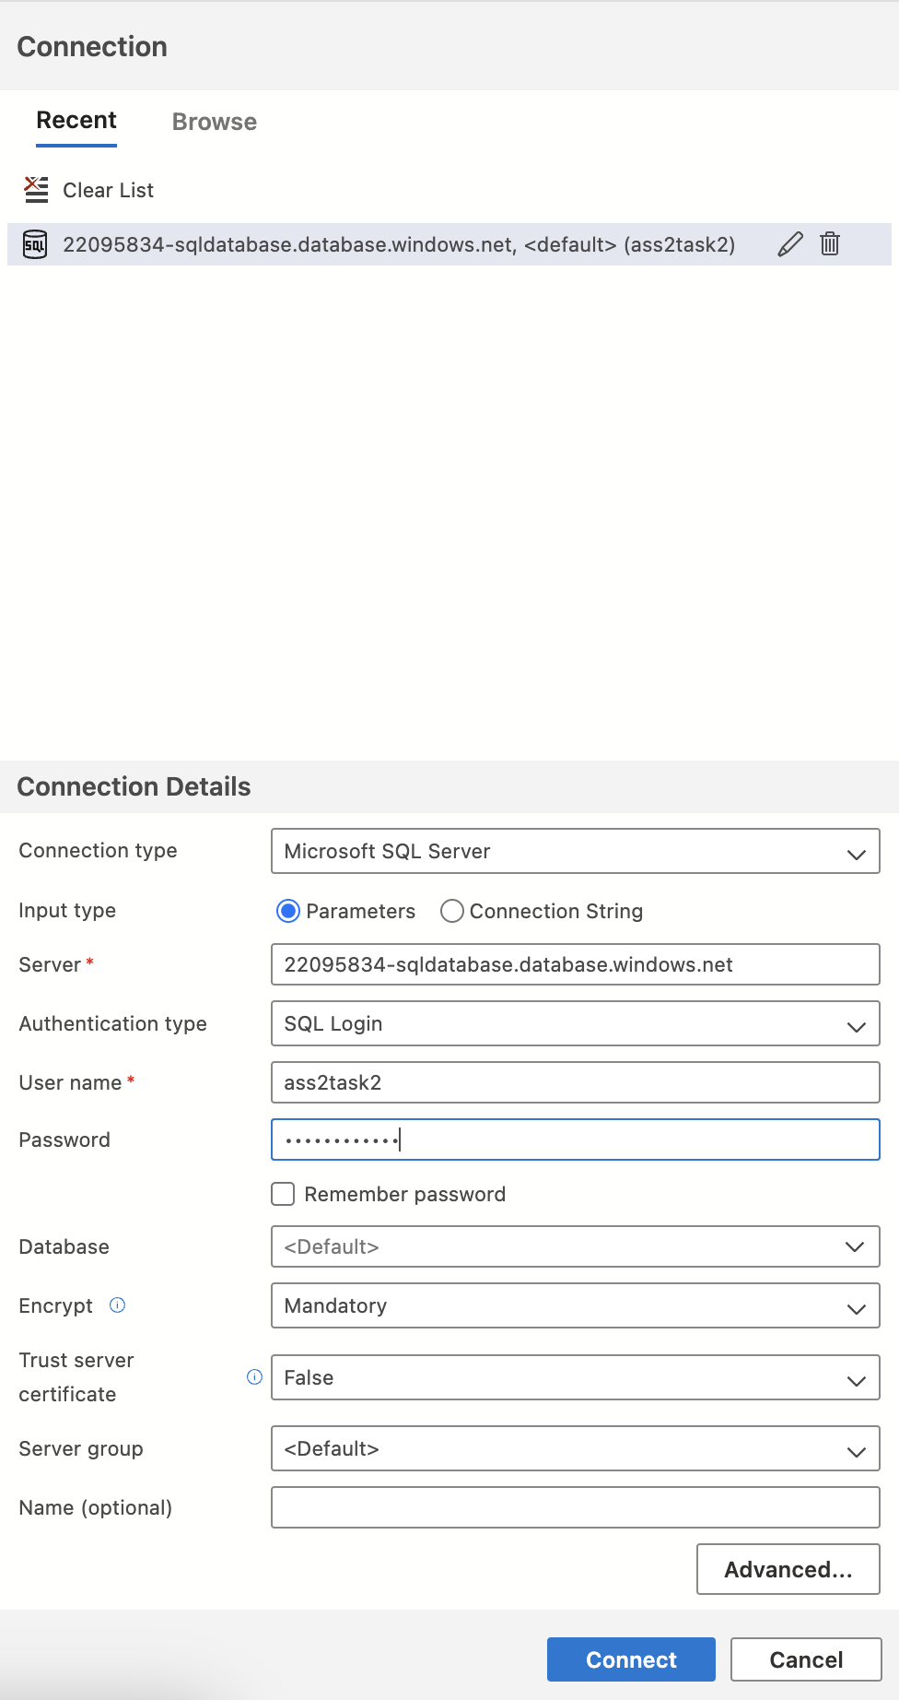

To connect to the Azure SQL Database, the required connection properties, including SQL Server name (22095834-sqldatabase.database.windows.net), Username, SQL login, password and other details, and the specific database (ass2task2), were provided correctly. Other additional connections, such as encryption, were also fixed to mandatory. After completing all the steps, the Connect Button was highlighted to establish the link. Hence, access to the Azure SQL Database was achieved, enabling the retrieval of the Northwind database and eventually carrying out the queries.

### What is the catalogue of all products along with their categories and unit price?

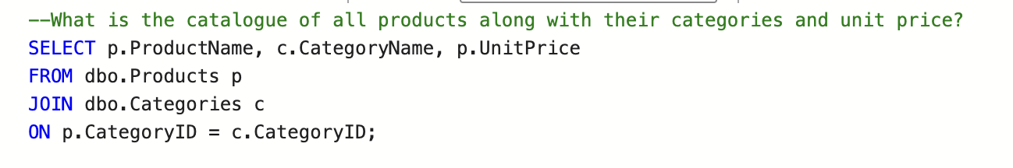

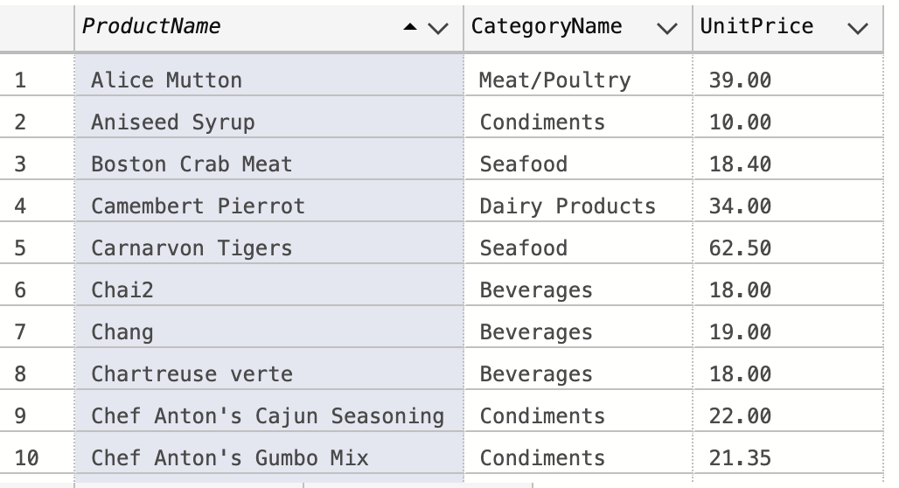

### What were the top performing product categories by the total revenue generated?

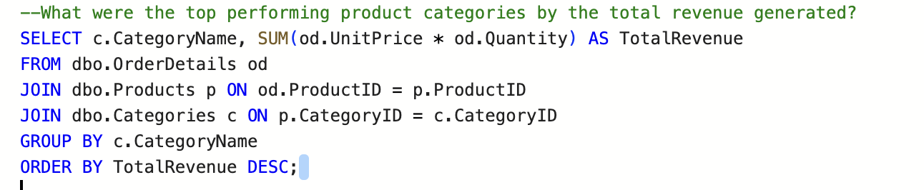

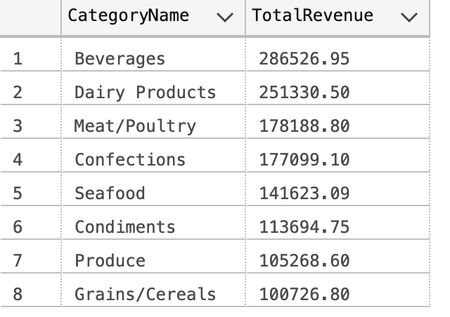

### Who were the top performing employees by the number of orders handled?

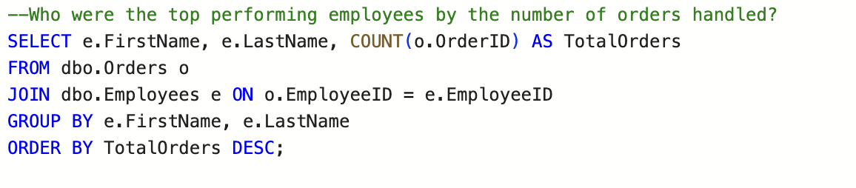

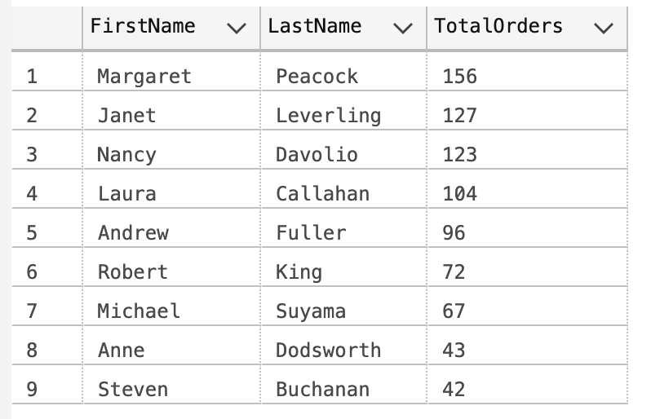

Additional Questions:

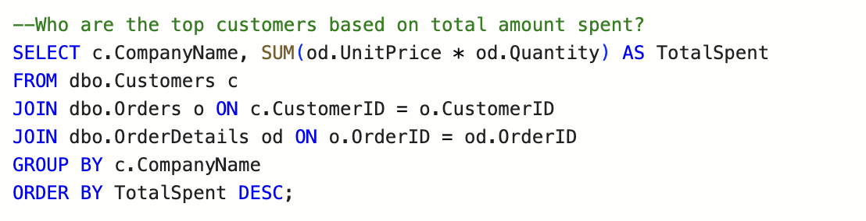

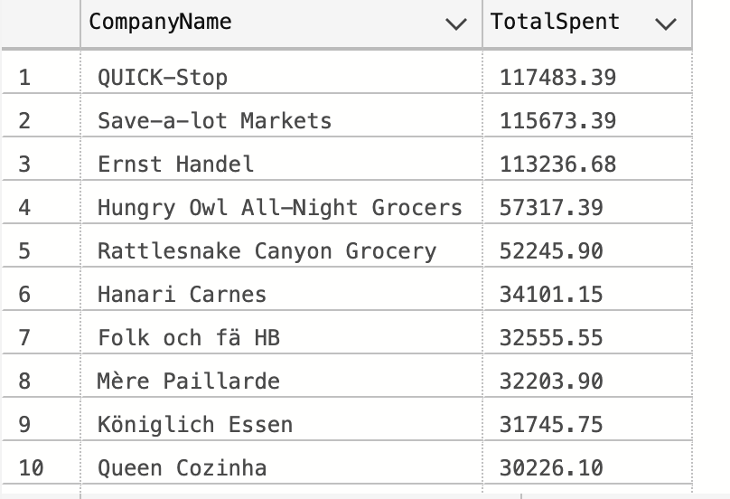

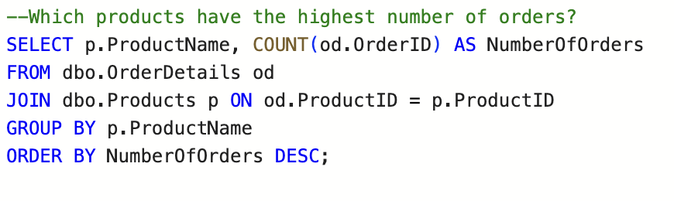

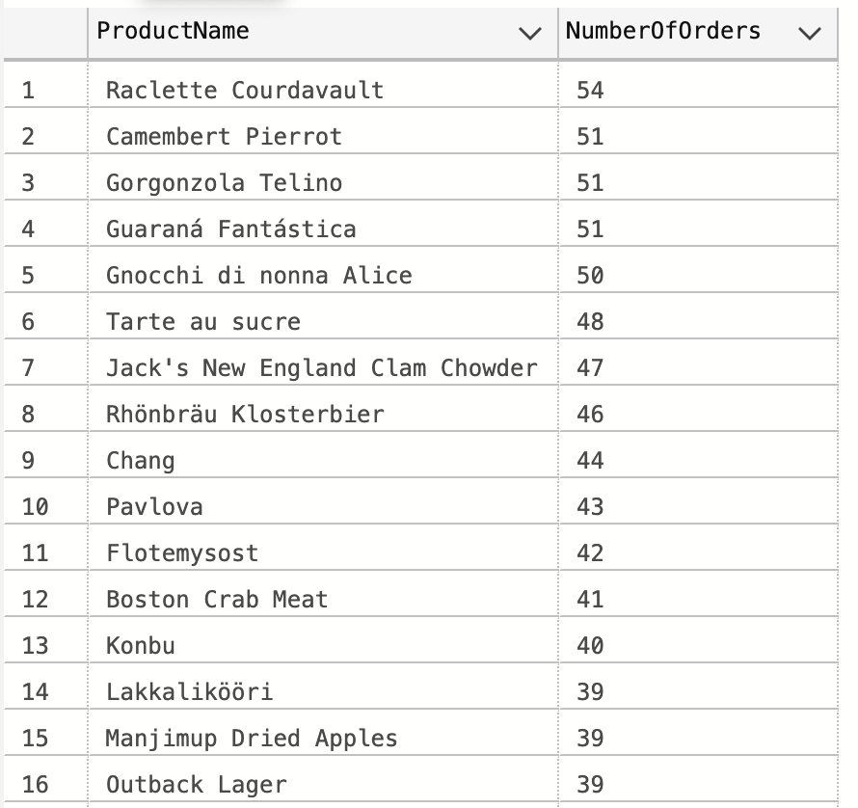

## 2 How would you automate the restoration process to ensure business continuity in future incidents

In the face of potential disruptions to the business, one of the most critical components of the plan is the ability to automate data recovery systems. With Azure SQL Database, automatic backups are available, which makes this scenario possible. More importantly, the backup retention period issue should be addressed with great caution to meet the loss reduction goals and ensure it is correctly set. Moreover, in addition to automated backups, opt for a periodic export of Bacpac files using an automated process. This process can be done using Azure Automation or Azure Logic Apps, where the database can be automatically exported to a secure place in Azure Blob Storage. This way, one has the latest backup whenever one wishes to review them. To further help with disaster recovery, auto-failover groups and geo-replication could be implemented. With auto-failover set up between the primary database and the geo-replica in another region, when the primary fails, the system switches to the secondary region almost immediately, hence keeping the system up for more hours or maybe no downtimes. In the case of geo-replication, read replicas for that database are available in various regions, so there is an extra chance of recovering and restoring data. Moreover, for security reasons, it is recommended that notifications be created using Azure Monitor. This will alert immediately if backup failures or issues within the automated recovery mechanisms occur. Verifying the backup and recovery plan will imply testing restoration methods by automating recovery tests. Doing a live restoration of backed-up files within at least a test environment regularly helps solve the problem of having a backup system that works when needed. Provided that these elements are combined, including automated backups, .bacpac exports, geo-replication and frequent backups, the aim of minimise manual interventions during the disaster recovery process in case of database failures, and hence ensure business resumption can be achieved.

# Q3. Conduct an exploratory analysis of the NYC Taxi Limousine Commission dataset using Databricks

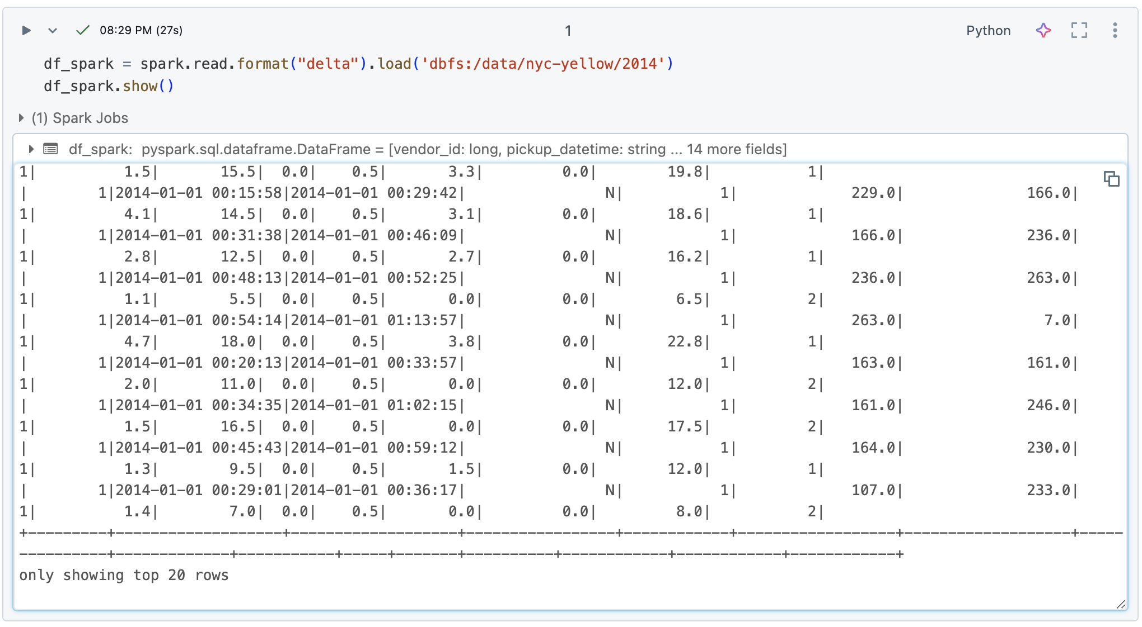

The first stage starts with loading the NYC Taxi dataset into Databricks, represented by the DataSet/DataFrame API within the Spark framework. Here, the dataset is saved in Delta format; hence, in code, it reads the data from the delta table (dbfs:/data/nyc-yellow/2014). For debugging purposes, the df_spark.show() command displays the first 20 rows of the dataset. The specified dataset contains many fields such as vendor_id, pickup_datetime, trip_distance, fare_amount, passenger_count, and others that must be provided to compute each trip's carbon footprint.

## Estimate the carbon emissions for each taxi ride. using the following emission factor: 8.89 kg of CO2 per gallon of gasoline burned

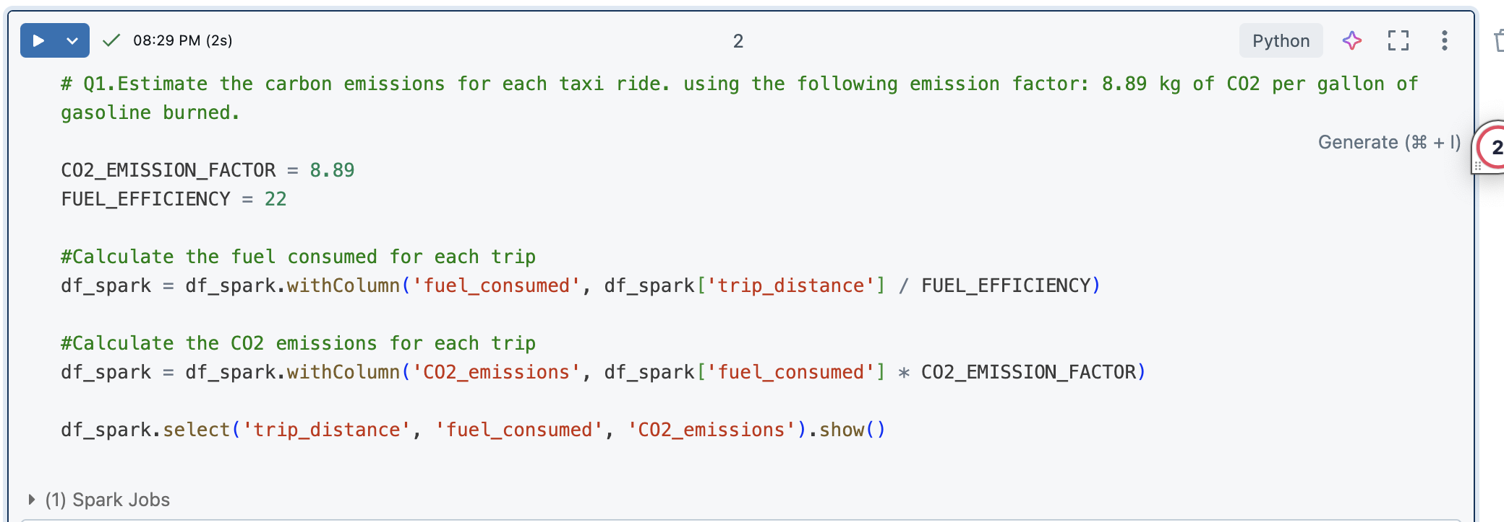

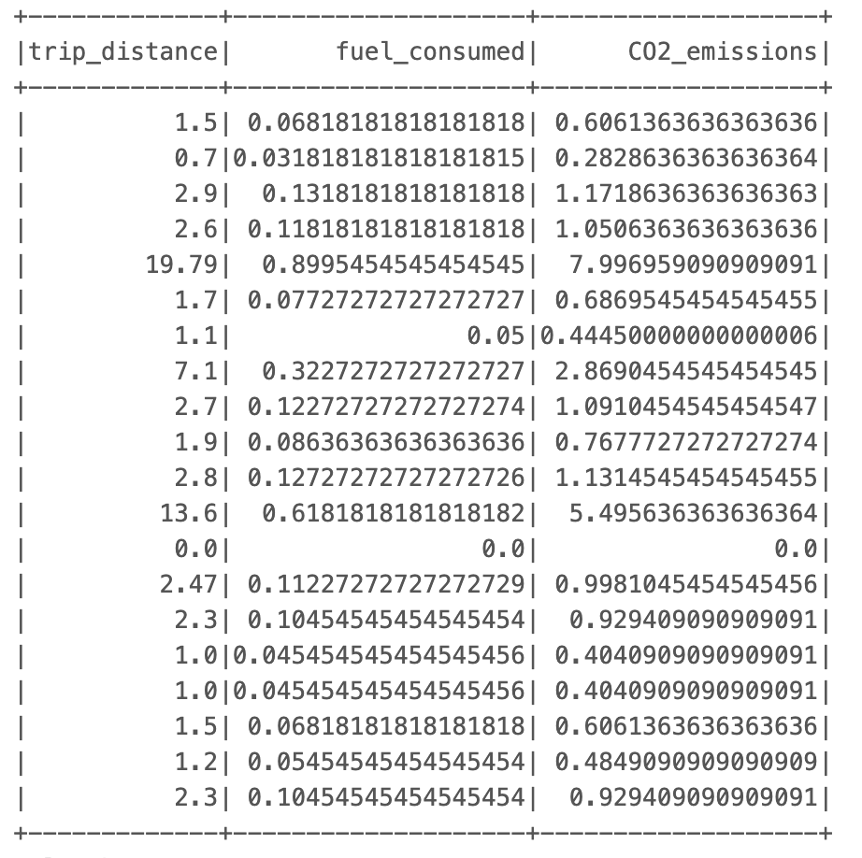

## Plot the total emissions per day over the year, comparing rides with 1-2 passengers versus rides with larger groups (3 or more passengers)

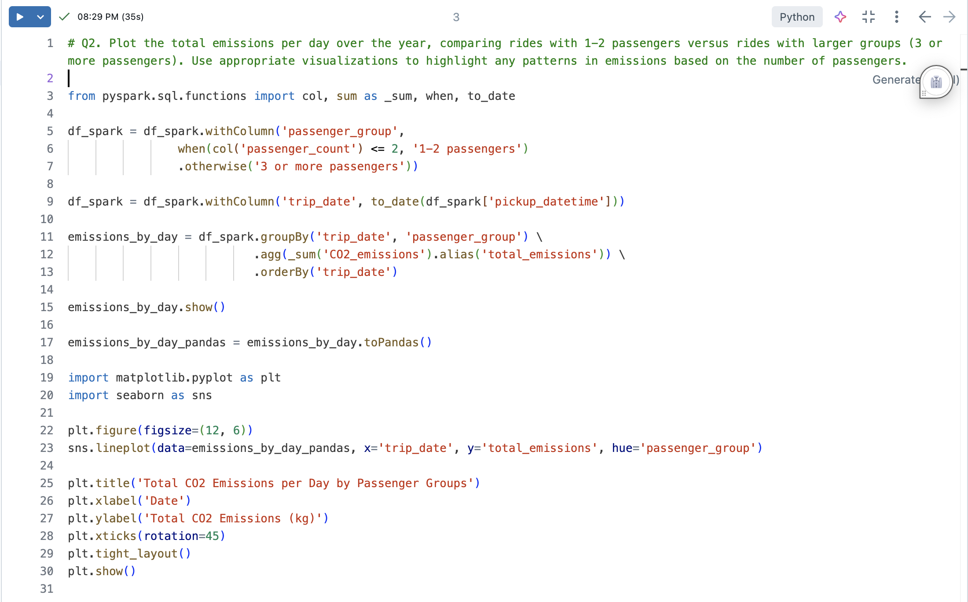

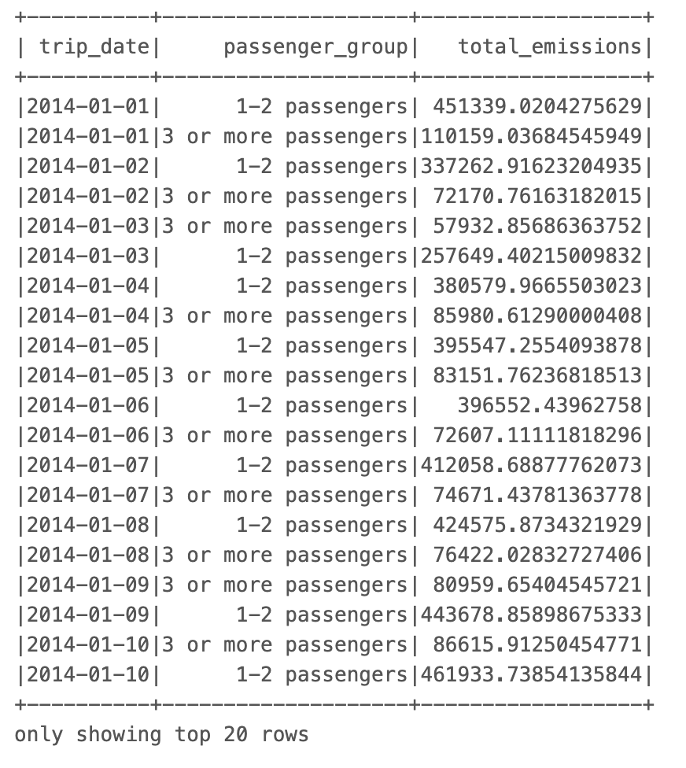

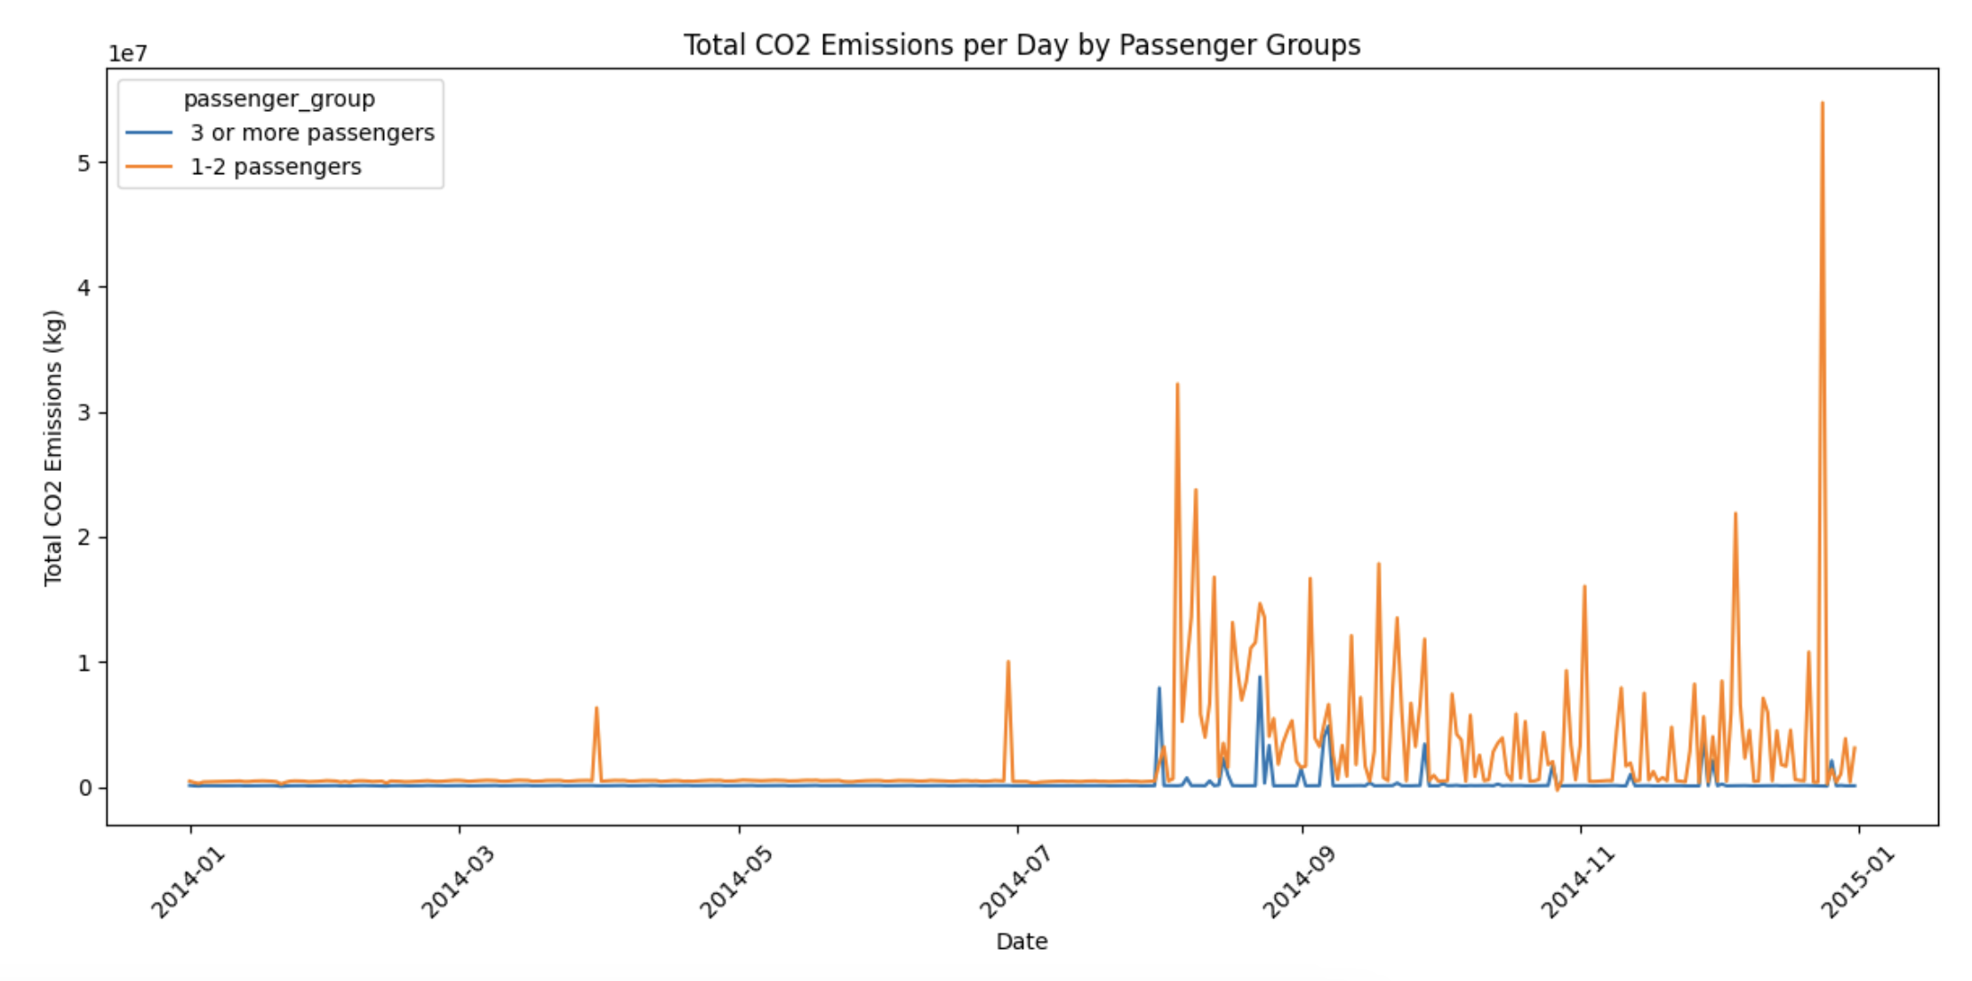

## Based on your analysis, suggest ways to reduce carbon emissions from taxi rides. Provide practical recommendations based on your findings

First, the fulfilment of ride-sharing and carpooling services should be considered because it considerably minimizes the quantities of CO2 all the vehicles will eventually emit. The technical results prove that traditionally, single-person and two-passenger car rides are even more harmful than those with three or more passengers. Frequently using a taxi becomes less common for passengers who resort to ridesharing, helping to reduce the number of taxi services and the quantity of fuel consumed with the corresponding passive effect on carbon emissions. It is also possible for taxi drivers to incorporate the costs of taxi cabs and car rents in the shared fare. This also makes it less likely that transportation will be expensive.

Another essential point is to use the existing resources meant for transportation effectively. The data analysis shows that fuel for running equipment is a part of the total CO2 produced. The current taxi systems and cabs must be converted to fuel-efficient or fully electric to save on fuel. This would significantly reduce the number of pollutants caused by a single ride. Many taxi shuttle companies can obtain modern vehicles by eliminating the older ones, which are more fuel-efficient or eco-friendly. The government can also support taxi providers by extending green policies such as grants or tax exemptions on cleaner vehicles.

Lastly, imposing a congestion charge in mainly crowded cities may be considered expedient. Making people pay a fee for access to some congested regions of the city at peak hours would help reduce unnecessary trips, which would, in turn, reduce the number of out-of-gas taxicabs in traffic and, as a result, prevent an increase in fuel consumption and emissions. Such prices of the services would lead to better use of the service cabs, promote multi-occupant taxi rides and therefore boredom the use of public transport.

Taken together, the above can reshape the taxi operation for the better, thus preventing adverse environmental implications for the transport sector in the city.